ST AUSTELL TOWN COUNCIL
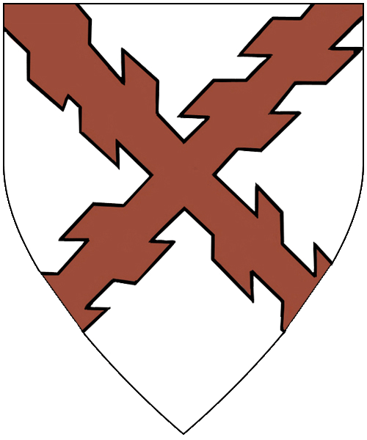

Notice is hereby given that St Austell Town Council has a vacancy for:

- One councillor for St Austell - Poltair & Mount Charles Ward

The vacancy will be filled by co-option at the Council meeting on Monday 15th December 2025 at 6pm in Chi Austel, White River Place, St Austell, Cornwall, PL25 5AZ

If you are interested in applying for this responsible role, please download a form from www.staustell-tc.gov.uk and check that you meet the qualification criteria.

Alternatively, you can check the qualification criteria and obtain a form by calling 01726 829854 or by email to david.pooley@staustell-tc.gov.uk

Completed forms should be returned to:

David Pooley
Town Clerk
St Austell Town Council
The Stable Block
Pondhu House,
Penwinnick Road
St Austell
Cornwall PL25 5DP

Or:

E-mail: david.pooley@staustell-tc.gov.uk

by 12 noon on Friday 5th December 2025

If you have any questions or would like an informal discussion about the role, please contact the Town Clerk.

Please note: Applications received after this date will not be considered.

